THE HISTORY OF LINSLADE RECREATION GROUND COMMUNITY GARDEN
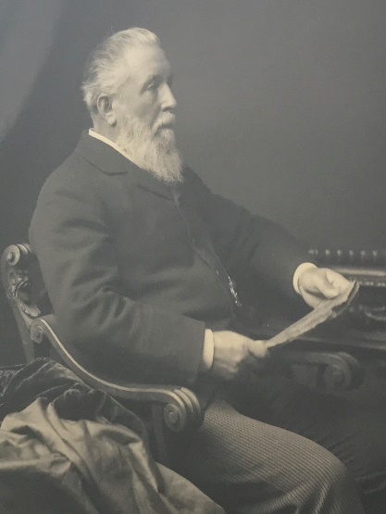
With the rapid expansion of the new Linslade in the early 19th century, it was felt that there was a need for a new parish church located at a more convenient spot than St. Mary's in Old Linslade. The church which was built (St Barnabas) was separated from the railway line and Leighton Buzzard Station by a green area. This area was saved from development by London financier and local benefactor Henry Finch. He was the first chairman of Linslade Urban Council and he was very generous to the local community.

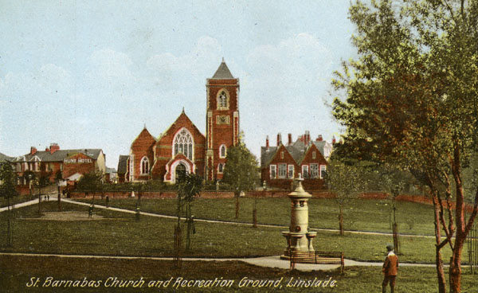

Henry Finch purchased the fields by the railway station at full market value for the people of Linslade. A park was attractively laid out with paths and avenues of pollarded lime trees. In August 1903 a memorial drinking fountain was erected, in memory of the town's greatest benefactor, by the people of Linslade. Even today Linslade Recreation Ground is an important greenspace used by many people.
THE LINSLADE COMMUNITY GARDEN
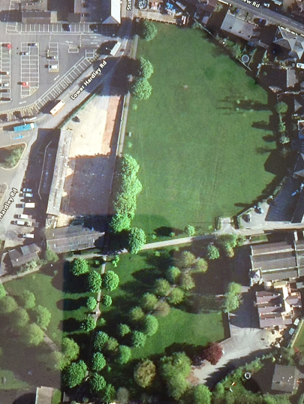
As the Friends of Leighton-Linslade in Bloom had developed a Community Garden in 2014 in Page’s Park, the group wanted to create a similar area in Linslade. The intial development started in 2016 when, with the help of the Town Council, a ‘Bags for Help’ grant was applied for from Tesco Supermarkets. We received £10,000 which was to be used for the hard landscaping. The area chosen for the planned garden was directly in front of St Barnabas Church where there was still a very small section of garden with lavendar and box plants. Previously there had been a small rose garden which had long since disappeared.
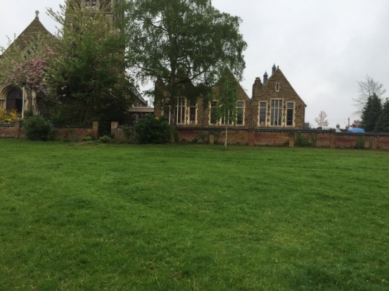
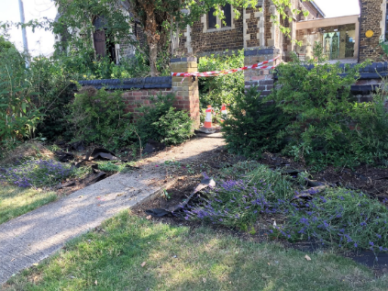
The Garden
Leighton Buzzard station

View looking toward St Barnabas Church and the remains of the former flower bed.
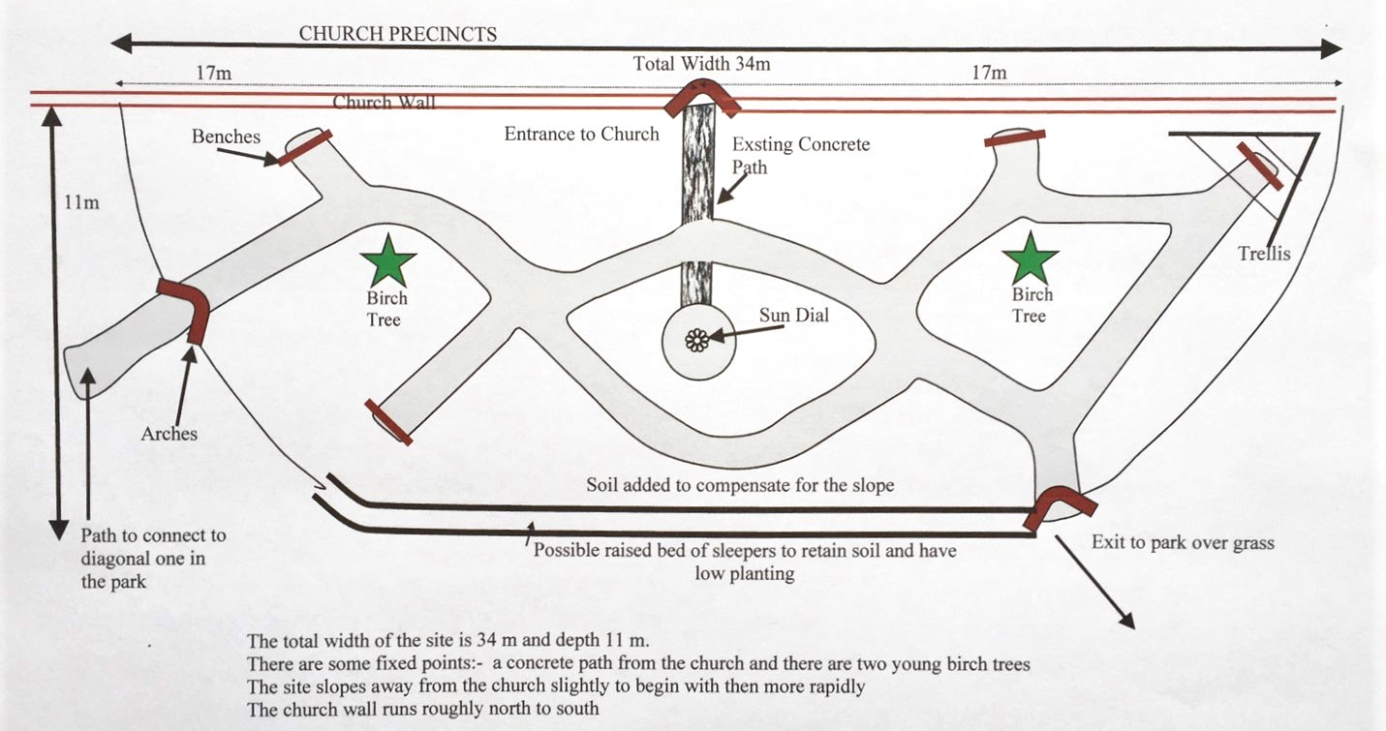The original plan
The specific location for the garden was decided by the Town Council which is the custodian of Linslade Recreation Ground. The actual design was created by two members of the group. There were certain constraints as central to the church wall was a gap allowing foot access, while the park sloped away from the wall and two young silver birch trees were already on the area selected for the garden. Plans were drawn. The garden was to be of a semi circular form with the gap to the church being central and the two existing young silver birch trees being within different beds. To reduce the slope, although it couldn’t be totally eliminated, a low wall of wooden sleepers was proposed. The garden’s hard landscaping was installed by a local landscaping firm in the summer of 2017. This took roughly a fortnight but the beds couldn’t be worked on by the volunteers until September 2017 as it was the summer holidays. The final garden layout was changed a little from the original plan (above) to incorporate a much larger central circular rose bed. The sleeper wall was constructed and soil added to some of the lower beds to try to reduce the slope. There were three entrances to the garden planned, each of which would have an arch. The gap in the church wall already had a very short concrete path, originally incorporated in the design, which had to be removed to allow the formation of the large central circular bed. A new path was laid from the garden towards the north to meet the existing diagonal one which crosses the park. The final path led on to the grass in the park to the east. Brown recycled plastic path edging was used to divide the beds from the paths. This was selected for its longevity and use of sustainable recycled plastic. The paths themselves were of Hoggin which is a a mix of gravel, sand and clay that binds firmly when compacted, yet allows water to drain through it. Not only does it look attractive but it is easy to maintain, just requiring occasional weeding. It is best suited to footpaths as it won't withstand the wear and tear of vehicles. To allow it to become durable it required a period of hot dry weather,something which the winter of 2017/18 didn’t provide.The paths themselves were to be at least 1m wide to allow pushchair and wheelchair access and 4 bench bays were constructed. These were wide enough to have offset benches which would allow wheelchairs or pushchairs to be placed facing the garden and next to the bench. The beds were given a number and initial planting schemes devised throughout the following months.
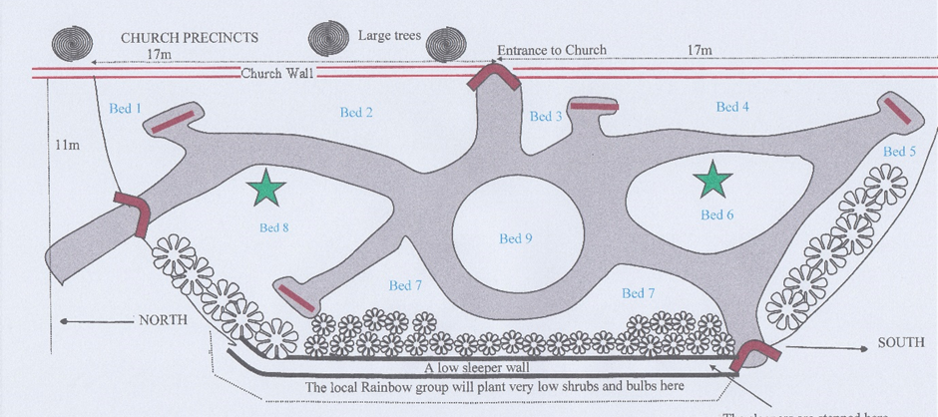
The final plan after the landscapers has created the paths and beds
There were originally 9 beds but as two were very small this was quickly changed to 7. Originally these had no names, just numbers but slowly over time they have been given names.
Beds 1 and 2 have become the White Bed
Beds 3 and 4 have become the Red Bed
Bed 5 is the Sunny Bed
Bed 6 is the Oval Bed
Bed 7 is the Long Bed
Bed 8 is the Shrub Bed
Bed 9 is the Rose Bed
